Unit :5

Collaborative Filtering in Machine Learning

If this time you are watching a horror video on youtube then next time you will automatically see some more horror videos in your feed have you ever thought about how this thing works? Like how an application was able to get to know about your choices and likes. This is exactly what is popularly known as Recommendation Systems.

What is a Recommendation system?
There are a lot of applications where websites collect data from their users and use that data to predict the likes and dislikes of their users. This allows them to recommend the content that they like. Recommender systems are a way of suggesting similar items and ideas to a user’s specific way of thinking.
There are basically two types of recommender Systems:
- Collaborative Filtering: Collaborative Filtering recommends items based on similarity measures between users and/or items. The basic assumption behind the algorithm is that users with similar interests have common preferences.
- Content-Based Recommendation: It is supervised machine learning used to induce a classifier to discriminate between interesting and uninteresting items for the user.
In this article, we will mainly focus on the Collaborative Filtering method.

What is Collaborative Filtering?
In Collaborative Filtering, we tend to find similar users and recommend what similar users like. In this type of recommendation system, we don’t use the features of the item to recommend it, rather we classify the users into clusters of similar types and recommend each user according to the preference of its cluster.
There are basically four types of algorithms o say techniques to build Collaborative filtering recommender systems:
- Memory-Based
- Model-Based
- Hybrid
- Deep Learning

Advantages of Collaborative Filtering-Based Recommender Systems
As we know there are two types of recommender systems the content-based recommender systems have limited use cases and have higher time complexity. Also, this algorithm is based on some limited content but that is not the case in Collaborative Filtering based algorithms. One of the main advantages that these recommender systems have is that they are highly efficient in providing personalized content but also able t adapt to changing user preferences.

Measuring Similarity
A simple example of the movie recommendation system will help us in explaining: 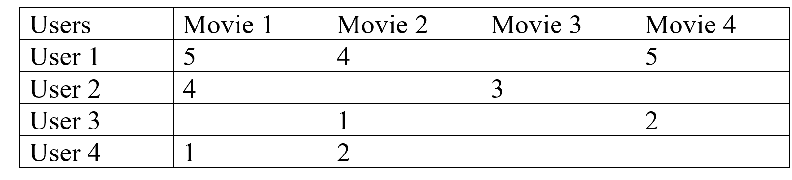

In this type of scenario, we can see that User 1 and User 2 give nearly similar ratings to the movie, so we can conclude that Movie 3 is also going to be averagely liked by User 1 but Movie 4 will be a good recommendation to User 2, like this we can also see that there are users who have different choices like User 1 and User 3 are opposite to each other. One can see that User 3 and User 4 have a common interest in the movie, on that basis we can say that Movie 4 is also going to be disliked by User 4. This is Collaborative Filtering, we recommend to users the items which are liked by users of similar interest domains.

Cosine Similarity
We can also use the cosine similarity between the users to find out the users with similar interests, larger cosine implies that there is a smaller angle between two users, hence they have similar interests. We can apply the cosine distance between two users in the utility matrix, and we can also give the zero value to all the unfilled columns to make calculation easy, if we get smaller cosine then there will be a larger distance between the users, and if the cosine is larger than we have a small angle between the users, and we can recommend them similar things.

Rounding the Data
In collaborative filtering, we round off the data to compare it more easily like we can assign below 3 ratings as 0 and above of it as 1, this will help us to compare data more easily, for example: 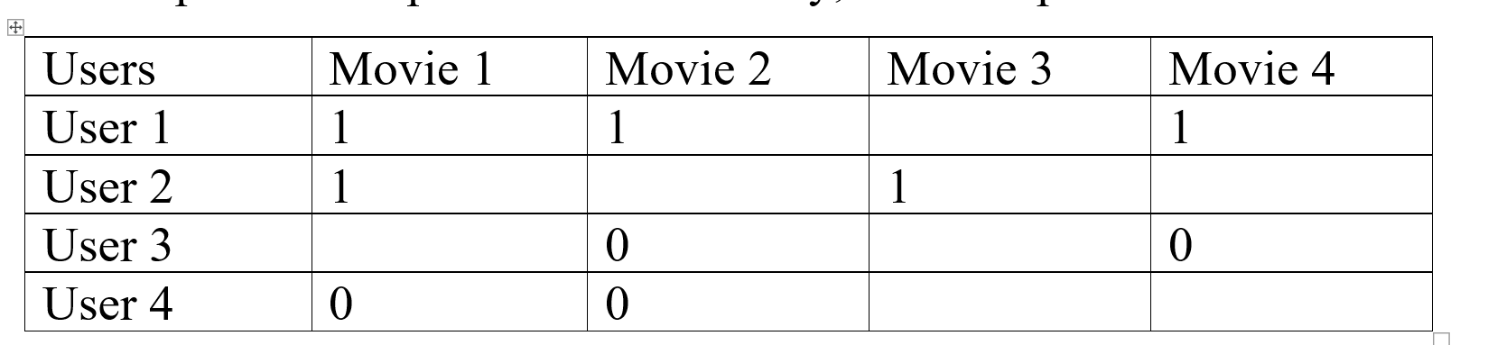

We again took the previous example and we apply the rounding-off process, as you can see how much more readable the data has become after performing this process, we can see that User 1 and User 2 are more similar and User 3 and User 4 are more alike.

Normalizing Rating
In the process of normalizing, we take the average rating of a user and subtract all the given ratings from it, so we’ll get either positive or negative values as a rating, which can simply classify further into similar groups. By normalizing the data we can make clusters of the users that give a similar rating to similar items and then we can use these clusters to recommend items to the users.

What are some of the Challenges to be Faced while using Collaborative Filtering?
As we know that every algorithm has its pros and cons and so is the case with Collaborative Filtering Algorithms. Collaborative Filtering algorithms are very dynamic and can change as well as adapt to the changes in user preferences with time. But one of the main issues which are faced by recommender systems is that of scalability because as the user base increases then the respective sizes for the computation and the data storage space all increase manifold which leads to slow and inaccurate results.
Also, collaborative filtering algorithms fail to recommend a diversity of products as it is based on historical data and hence provide recommendations related to them as well.

Item-to-Item Based Collaborative Filtering
Collaborative Filtering is a technique or a method to predict a user’s taste and find the items that a user might prefer on the basis of information collected from various other users having similar tastes or preferences. It takes into consideration the basic fact that if person X and person Y have a certain reaction for some items then they might have the same opinion for other items too.
The two most popular forms of collaborative filtering are:
- User Based: Here, we look for the users who have rated various items in the same way and then find the rating of the missing item with the help of these users.
- Item Based: Here, we explore the relationship between the pair of items (the user who bought Y, also bought Z). We find the missing rating with the help of the ratings given to the other items by the user.
Let’s talk about Item-Based Collaborative Filtering in detail. It was first invented and used by Amazon in 1998. Rather than matching the user to similar customers, item-to-item collaborative filtering matches each of the user’s purchased and rated items to similar items, then combines those similar items into a recommendation list. Now, let us discuss how it works.
Item to Item Similarity: The very first step is to build the model by finding similarity between all the item pairs. The similarity between item pairs can be found in different ways. One of the most common methods is to use cosine similarity.
Formula for Cosine Similarity:

Prediction Computation: The second stage involves executing a recommendation system. It uses the items (already rated by the user) that are most similar to the missing item to generate rating. We hence try to generate predictions based on the ratings of similar products. We compute this using a formula which computes rating for a particular item using weighted sum of the ratings of the other similar products.

Example:
Let us consider one example. Given below is a set table that contains some items and the user who have rated those items. The rating is explicit and is on a scale of 1 to 5. Each entry in the table denotes the rating given by a i^{th} User to a j^{th} Item. In most cases majority of cells are empty as a user rates only for few items. Here, we have taken 4 users and 3 items. We need to find the missing ratings for the respective user.
User/Item | Item_1 | Item_2 | Item_3
User_1 | 2 | – | 3
User_2 | 5 | 2 | –
User_3 | 3 | 3 | 1
User_4 | – | 2 | 2
Step 1: Finding similarities of all the item pairs.
Form the item pairs. For example in this example the item pairs are (Item_1, Item_2), (Item_1, Item_3), and (Item_2, Item_3). Select each item to pair one by one. After this, we find all the users who have rated for both the items in the item pair. Form a vector for each item and calculate the similarity between the two items using the cosine formula stated above.
Sim(Item1, Item2)
In the table, we can see only User_2 and User_3 have rated for both items 1 and 2.
Thus, let I1 be vector for Item_1 and I2 be for Item_2. Then,
I1 = 5U2 + 3U3 and,
I2 = 2U2 + 3U3

Sim(Item2, Item3)
In the table we can see only User_3 and User_4 have rated for both the items 1 and 2.
Thus, let I2 be vector for Item_2 and I3 be for Item_3. Then,
I2 = 3U3 + 2U4 and,
I3 = 1U3 + 2U4

Sim(Item1, Item3)
In the table we can see only User_1 and User_3 have rated for both the items 1 and 2.
Thus, let I1 be vector for Item_1 and I3 be for Item_3. Then,
I1 = 2U1 + 3U3 and,
I3 = 3U1 + 1U3

Step 2: Generating the missing ratings in the table
Now, in this step we calculate the ratings that are missing in the table.
Rating of Item_2 for User_1

Rating of Item_3 for User_2

Rating of Item_1 for User_4
Therefore, through this article, we tried to understand the basic working of item-to-item collaborative filtering with the help of a small example.

Component Procedures of a Recommender:
Recommenders mostly have 3 components:
- Candidate Generations: This method is responsible for generating smaller subsets of candidates to recommend to a user, given a huge pool of thousands of items.
- Scoring Systems: Candidate Generations can be done by different Generators, so, we need to standardize everything and try to assign a score to each of the items in the subsets. This is done by the Scoring system.
- Re-Ranking Systems: After the scoring is done, along with it the system takes into account other additional constraints to produce the final rankings.

Types of Candidate Generation Systems:
- Content-based filtering System
- Collaborative filtering System
Content-based filtering system: Content-Based recommender system tries to guess the features or behavior of a user given the item’s features, he/she reacts positively to.

The last two columns Action and Comedy Describe the Genres of the movies. Now, given these genres, we can know which users like which genre, as a result, we can obtain features corresponding to that particular user, depending on how he/she reacts to movies of that genre.
Once, we know the likings of the user we can embed him/her in an embedding space using the feature vector generated and recommend him/her according to his/her choice. During recommendation, the similarity metrics (We will talk about it in a bit) are calculated from the item’s feature vectors and the user’s preferred feature vectors from his/her previous records. Then, the top few are recommended.
Content-based filtering does not require other users' data during recommendations to one user.

